Supervised Learning Models on the Diabetes Prediction Dataset

Name: Shafay Sarwar Date: 23-10-2026

GitHub link:
Dataset:
- Source: Diabetes Prediction Dataset (Kaggle)
- Rows: 100,000 originally, 96,146 after removing 3,854 duplicates
- Columns: 9 (age, hypertension, heart_disease, bmi, HbA1c_level, blood_glucose_level, gender, smoking_history, diabetes)
- Target: diabetes (1 = has diabetes, 0 = no diabetes)
- Class balance: 87,664 rows are "No" (91.2%) and 8,482 rows are "Yes" (8.8%), so the data is imbalanced.
- Missing values: 0. Text columns gender aur smoking_history ko one-hot encoding se convert kiya
- Split: 80/20, test set = 19,230 rows
Results table:
Model | Accuracy | Precision | Recall | F1
KNN (K=13) | 0.961 | 0.955 | 0.583 | 0.724
Decision Tree (max_depth=2) | 0.972 | 1.000 | 0.678 | 0.808
Logistic Regression | 0.960 | 0.869 | 0.639 | 0.736
Confusion matrix of the best model (Decision Tree):
 | Predicted No | Predicted Yes
Actual No | 17,534 (TN) | 0 (FP)
Actual Yes | 546 (FN) | 1,150 (TP)

Best K and best max_depth:
Best K = 13. I tried all odd K values from 1 to 15. K = 13 gave the highest test accuracy (0.9608), while K = 5 gave 0.9592. K = 1 gave the lowest accuracy (0.9462) because it looks at only one neighbour, so it copies the noise in the data (overfitting). Larger K values average over more neighbours, so the predictions are more stable.
Best max_depth = 2. Depths 2, 3 and 5 all gave the same test accuracy (0.9716), so I chose depth 2 because it is the simplest tree. When the tree had no depth limit (None), the train accuracy was 0.999 but the test accuracy dropped to 0.947. This shows that a very deep tree memorizes the training data and overfits.
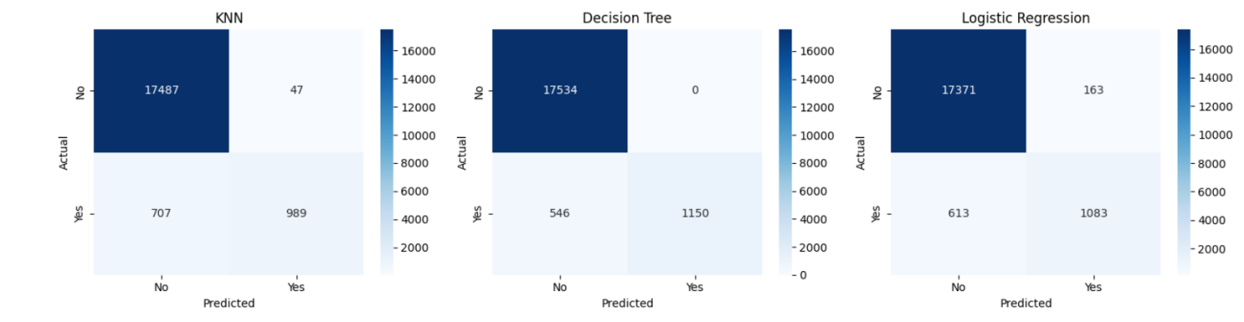
The Decision Tree correctly identified 17,534 healthy people (true negatives) and 1,150 diabetic patients (true positives). It never labelled a healthy person as diabetic (0 false positives). However, it missed 546 patients who actually have diabetes and called them healthy (false negatives). This is the most serious mistake for this problem, so the recall of this model (0.678) is not perfect.

Which metric matters most
Recall matters most for this problem. A false negative means a patient who has diabetes is told they are healthy, so the treatment starts late and can cause serious harm. A false positive only means a healthy person gets an extra test. So it is more important to catch as many diabetic patients as possible, which is what recall measures.
Accuracy alone is also misleading here. About 91% of the patients do not have diabetes, so a model that says “No” for everyone would already get 91.2% accuracy. The three models have 96-97% accuracy, but their F1-scores are only 0.72 to 0.81. This shows that F1 and recall give a more honest picture than accuracy on imbalanced data.

What I learned and problems I faced
What I learned
- On imbalanced data, accuracy can be misleading, so I should also check precision, recall and F1-score.
- Data preparation matters: I removed duplicate rows, converted the text columns to numbers with one-hot encoding, and fitted the scaler on the training data only to avoid data leakage.
- A simple model can work very well. A Decision Tree with depth 2 was better than KNN and Logistic Regression on this dataset.
- A very deep tree overfits, and a very small K in KNN overfits too.
Problems I faced
- The KNN loop was very slow because the dataset has about 96,000 rows. To fix this, I found the 15 nearest neighbours once and calculated the accuracy for each odd K from them.
- The best Decision Tree has 546 false negatives, so its recall (0.678) is still low. It misses some diabetic patients, and this should be improved in future work.
- I chose the best K and the best depth using the test set, as the assignment asked. A better method would be to use a separate validation set or cross-validation.

